LAB # 02
OBJECTIVE:
To implement and apply various activation functions in neural networks.
LAB TASKS:
- Implement a step function that outputs 1 if input ≥ 0, else 0.
• Input Values: [-3.0, -1.0, 0.0, 2.0, 5.0]
• Expected Output: [0, 0, 1, 1, 1]
• Visualization: Plot the step function for inputs between -5 to 5.

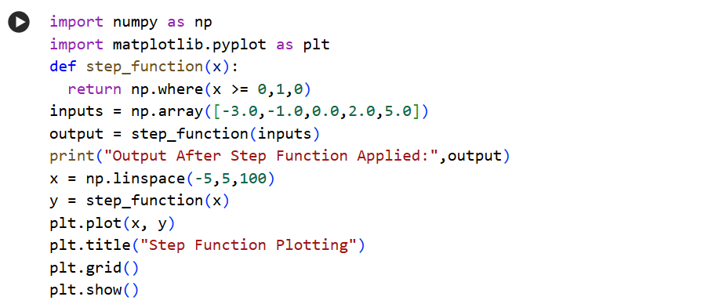
CODE:
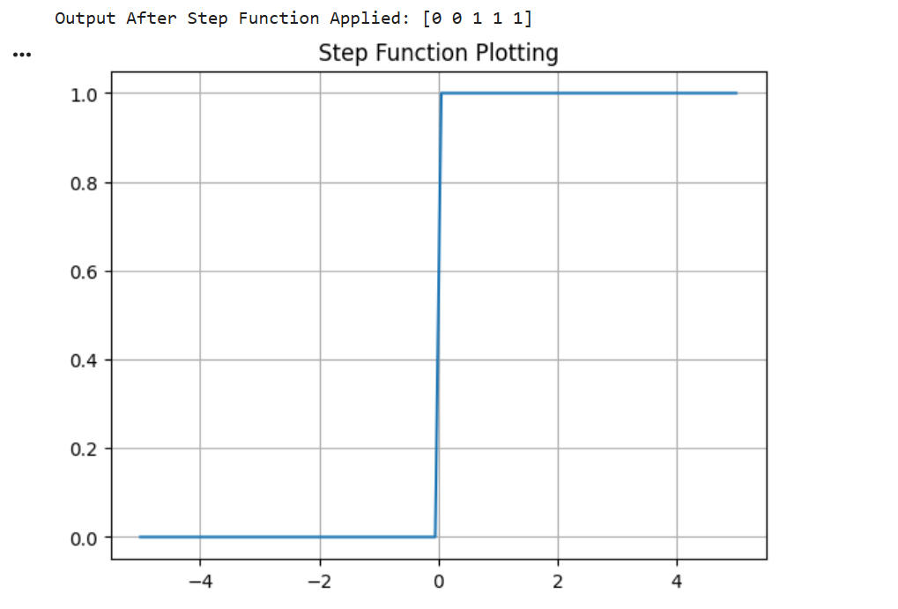
OUTPUT:

- Implement ReLU: f(x) = max(0, x).

• Input Values: [-4.0, -2.0, 0.0, 3.0, 5.0]
• Expected Output: [0, 0, 0, 3, 5]
• Visualization: Plot the ReLU graph between -5 and 5.
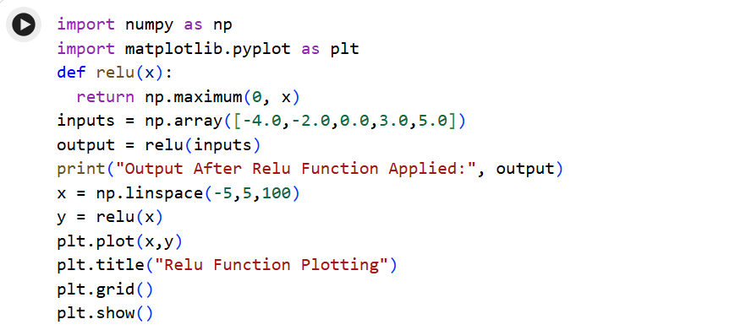
CODE:
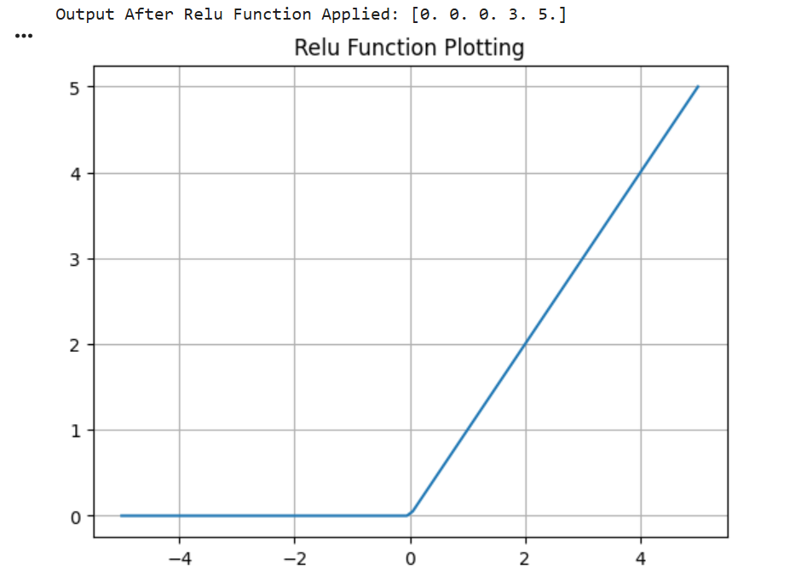
OUTPUT:

- Implement Sigmoid: f(x) = 1 / (1 + e^{-x}).

• Input Values: [-2.0, 0.0, 1.0, 3.0]
• Expected Output: ≈ [0.119, 0.5, 0.731, 0.953]
• Visualization: Plot the sigmoid curve and explain why sigmoid compresses values between 0 & 1.

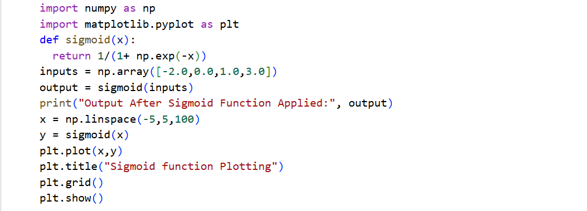
CODE:
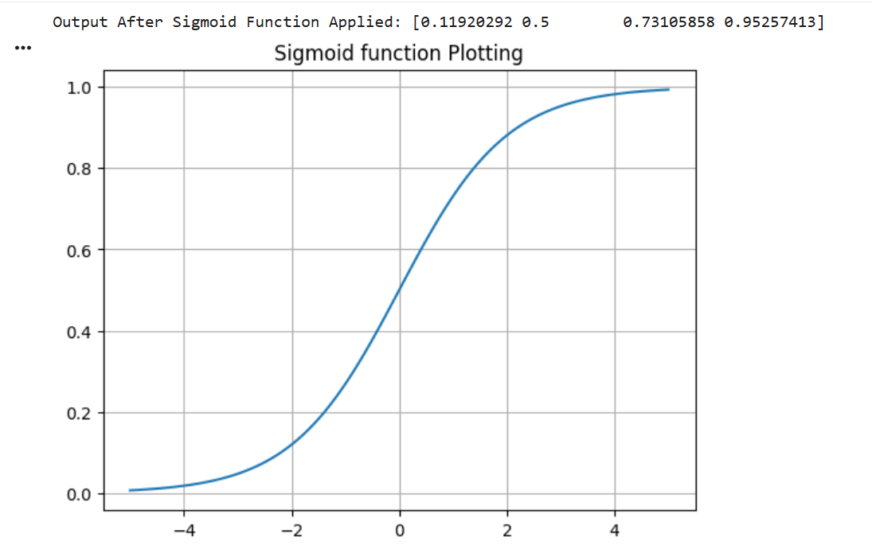
OUTPUT:
EXPLANATION WHY SIGMOID COMPRESSES VALUES:
Sigmoid compresses values between 0 and 1 because it is defined as 1/(1+e^{-x}) where the denominator is always greater than 1 making the output always lie between 0 and 1.
- Implement Tanh: f(x) = (e^x - e^{-x}) / (e^x + e^{-x}).

• Input Values: [-1.5, 0.0, 1.0, 2.0]
• Expected Output (approx): [-0.905, 0.0, 0.762, 0.964]
• Visualization: Plot Tanh and compare it with Sigmoid.
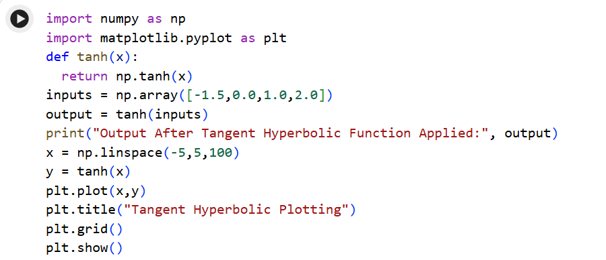
CODE:
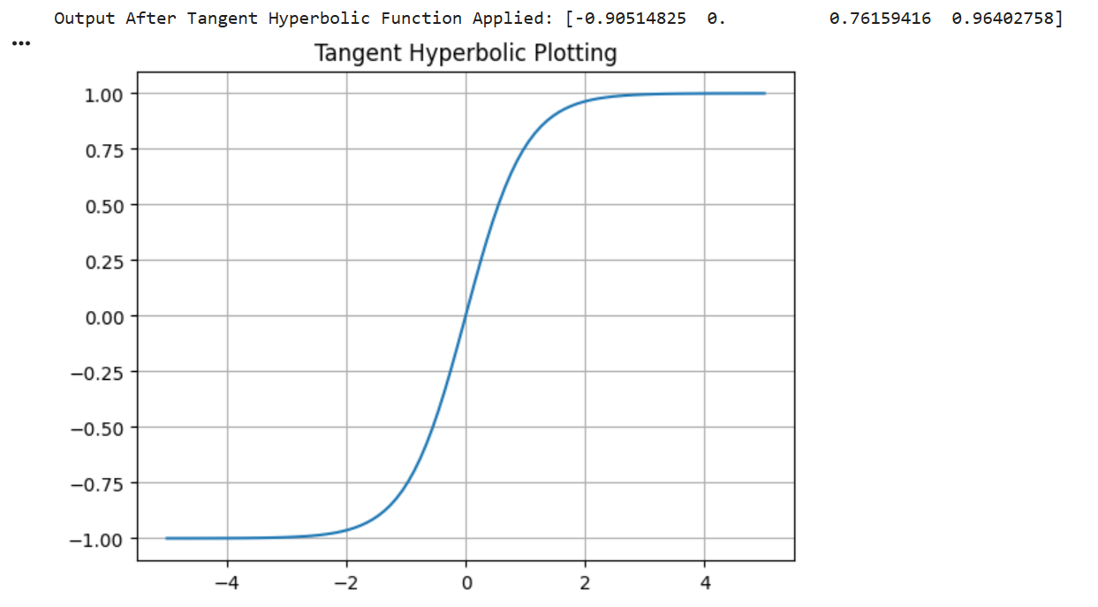
OUTPUT:

COMPARISON BETWEEN SIGMOID & TANGENT HYPERBOLIC:
SIGMOID | TANGENT HYPERBOLIC
Output range is 0 to 1. | Output range is -1 to 1.
Learning is slower. | Learning is faster.
Output always positive. | Output may be positive or negative both.
Graph shifted above x-axis. | Graph centered at origin.

- Implement Leaky ReLU: f(x) = x if x ≥ 0 else α*x.

• Input Values: [-3.0, -1.0, 0.0, 2.0]
• Test with α = 0.1: Expected Output → [-0.3, -0.1, 0.0, 2.0]
• Visualization: Plot Leaky ReLU for α = 0.1 and α = 0.3.
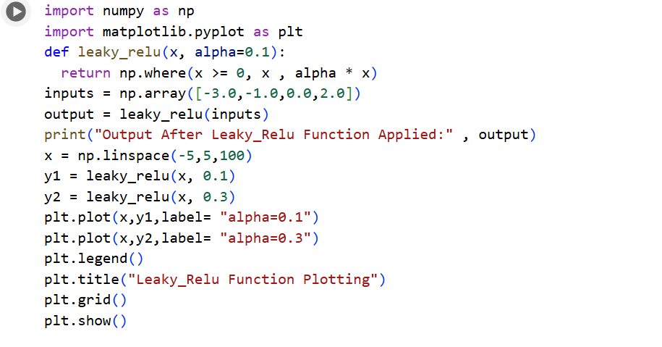
CODE:

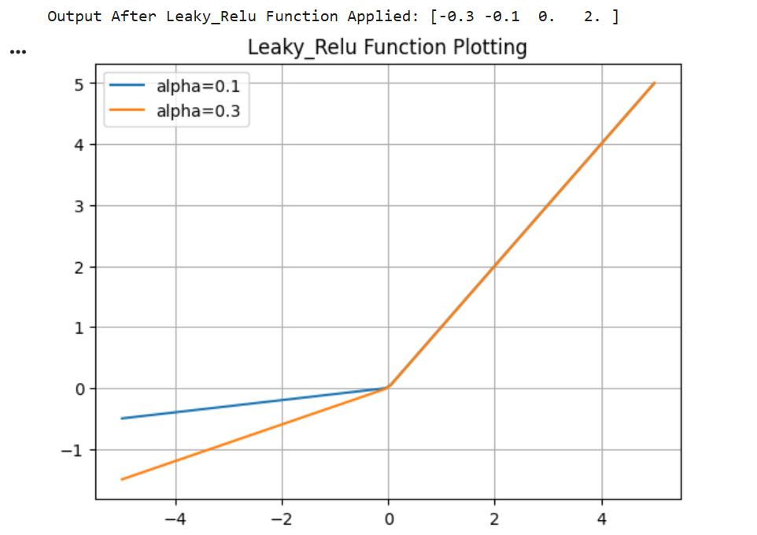
OUTPUT:
- Implement Softmax to convert inputs into probabilities.

• Input Values: [1.0, 2.0, 3.0]
• Expected Output (approx): [0.090, 0.245, 0.665]
• Explanation: Why the output values always sum to 1.
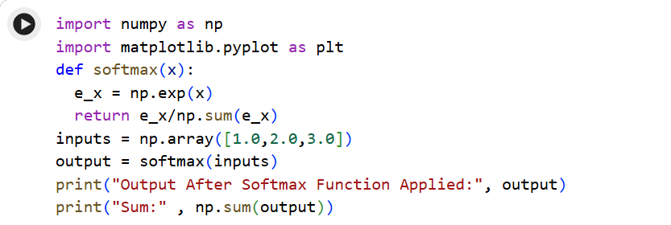
CODE:
OUTPUT:
WHY OUTPUT VALUES ALWAYS SUM TO 1:
Softmax outputs sum to 1 because each value is divided by the sum of all exponentials making the total equal to 1.

BONUS TASK:
Plot the following activation functions: Sigmoid, Tanh, ReLU, and Leaky ReLU on the same graph using an input range of -10 to 10. Use different colors and a legend to clearly identify each function. After plotting, create a short table showing the output range and main problem of each activation function. The task focuses on generating the graph and table only.
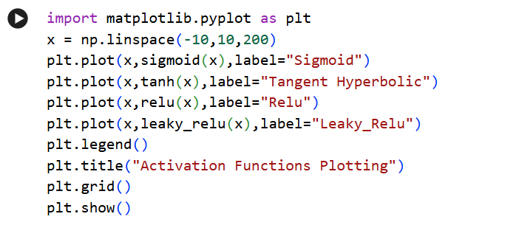
CODE:
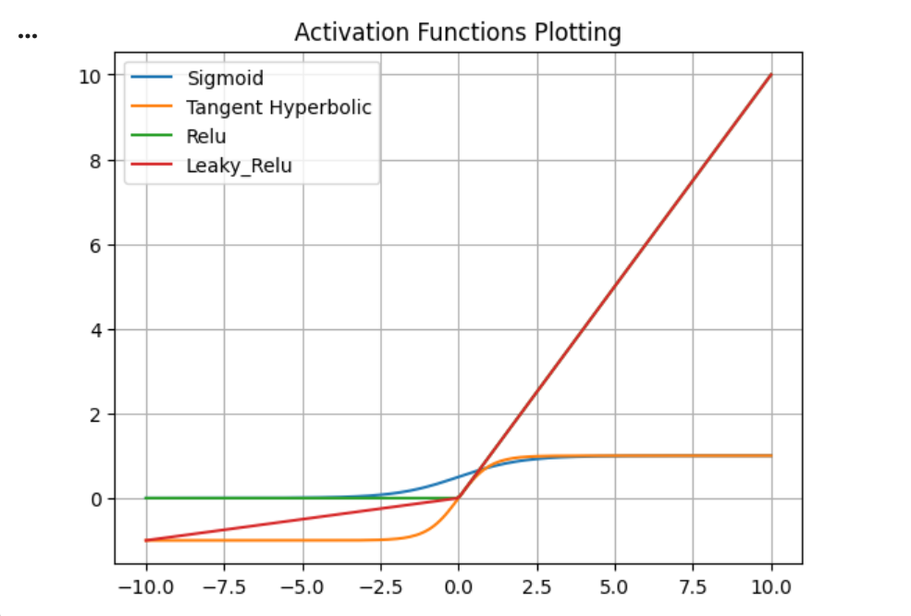
OUTPUT:
TABLE:
ACTIVATION FUNCTION | OUTPUT RANGE | MAIN PROBLEM
SIGMOID | (0,1) | Vanishing Gradient
TANGENT HYPERBOLIC | (-1,1) | Vanishing Gradient
RELU | [0,∞) | Dying Relu (neurons stop for negative values)
LEAKY_RELU | (-∞,∞) | Alpha selection issue

